Automate the setup of Linux, Apache, MySQL, and PHP on multiple servers

1)create all directories and files



2)check for the ping

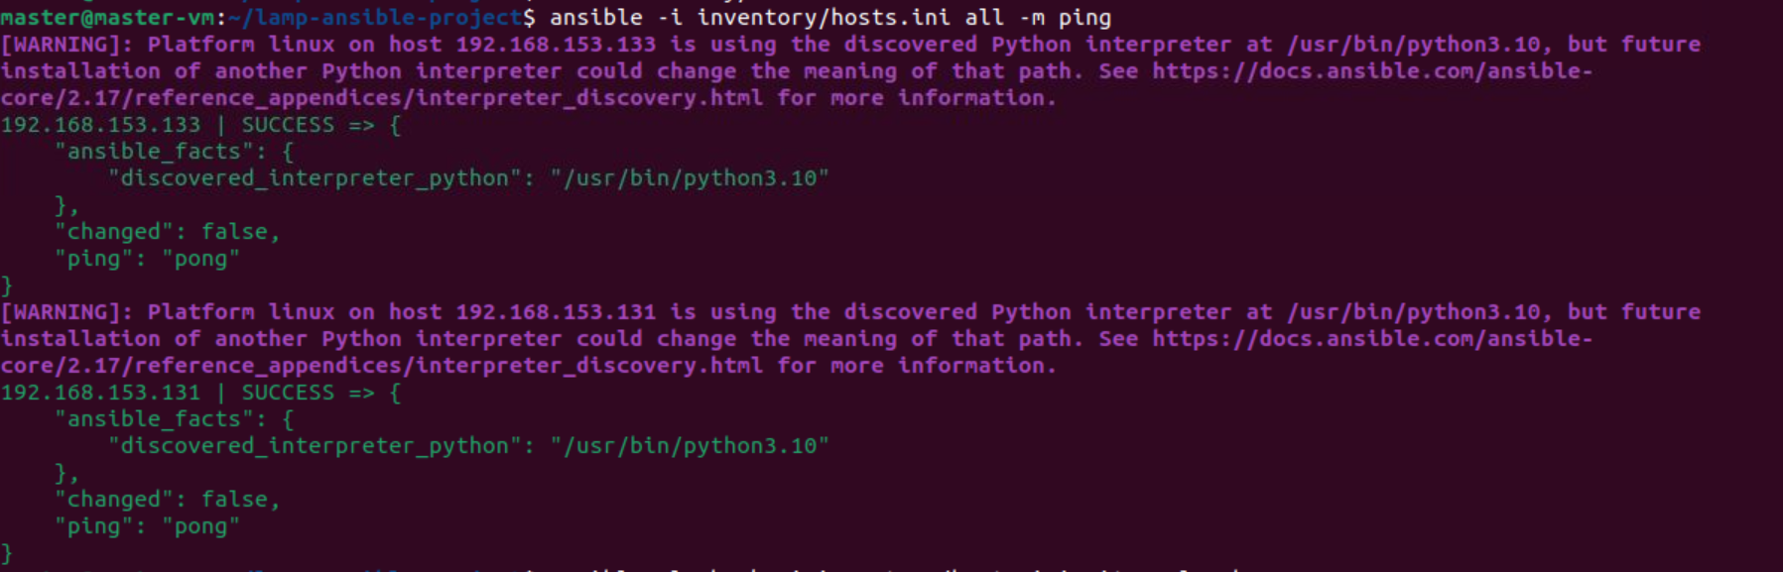

3)Now run the site.yml file

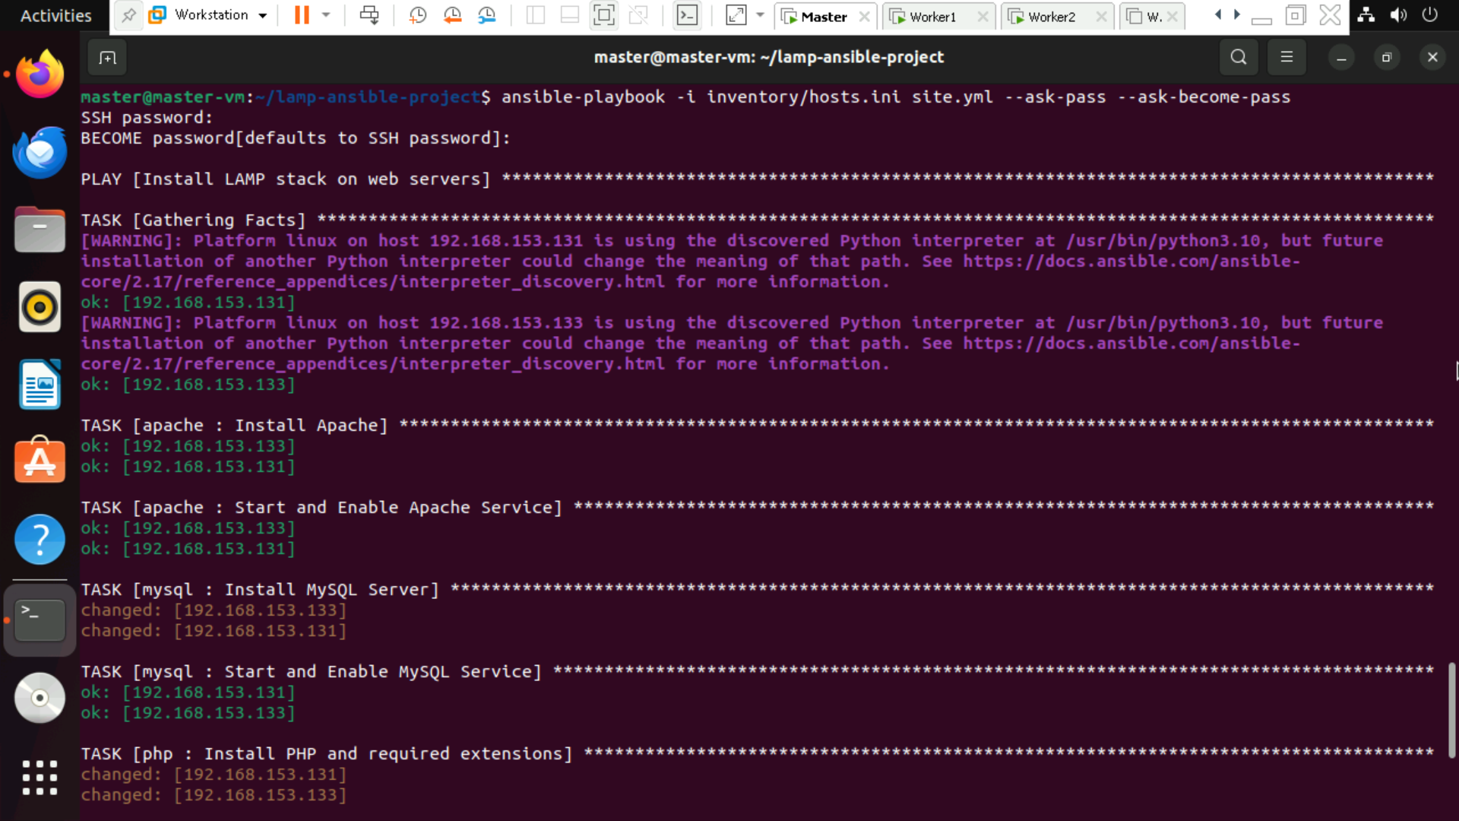

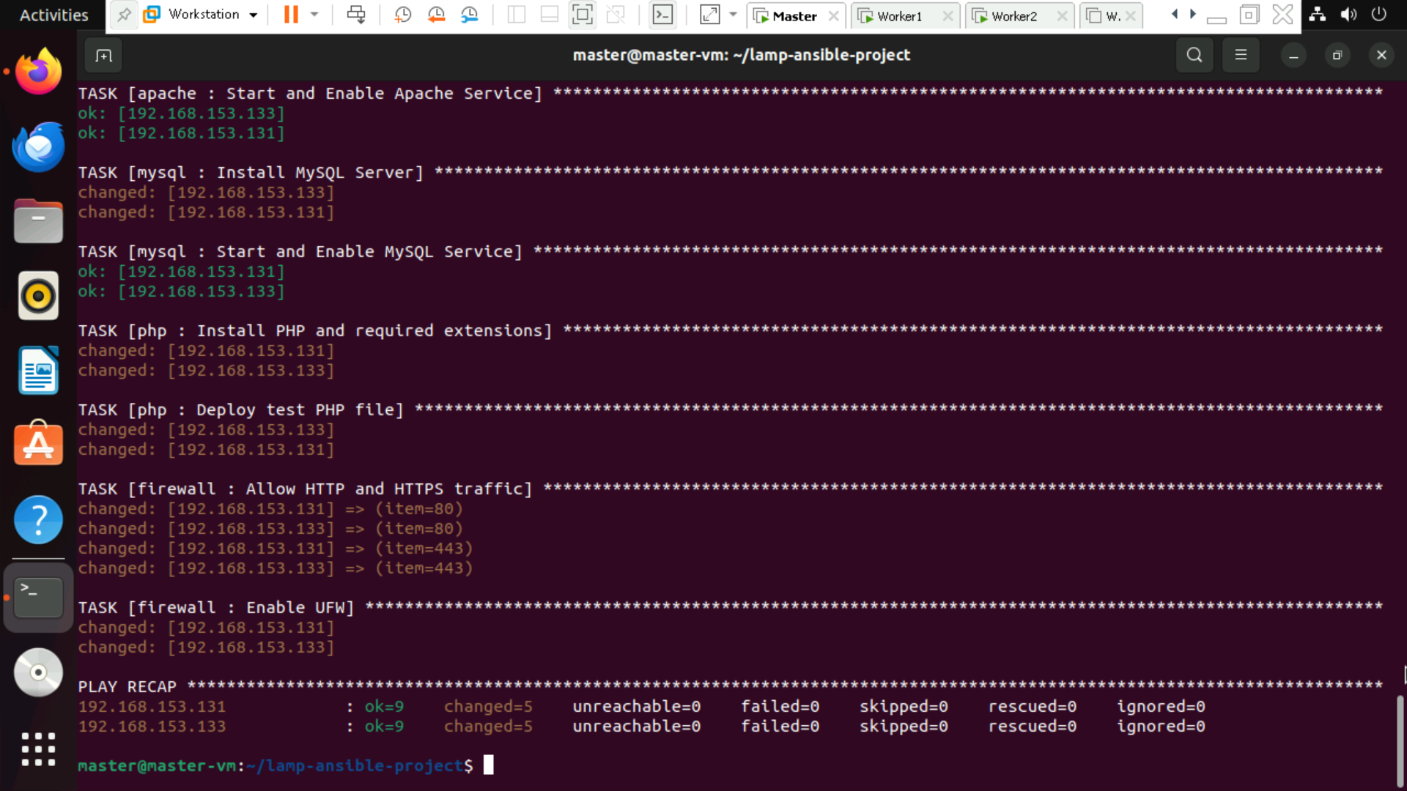

Output

